EXPERIMENT 3
PROCEDURE:
Develop a network simulator using cisco packet tracer to analyze packet delay, loss , and end-to-end throughput. Implement various routing algorithms and measure their impact on network performance under different traffic conditions.
AIM:
Network Simulator for analyzing Packet Delay, Loss, and throughput
PROCEDURE:
PHASE 1: Build the network
Step 1: open Packet Tracer
. Click File- New
Step 2: Add Devices
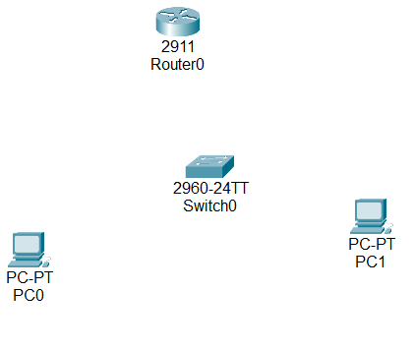
Step 3 : Connect Devices with cables
Use copper straight through cable
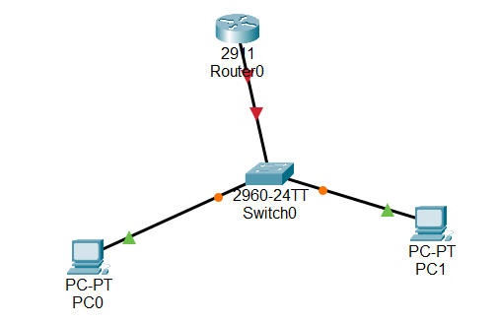
PHASE 2: Configure Router
Step 4: Click Router- CLI tab
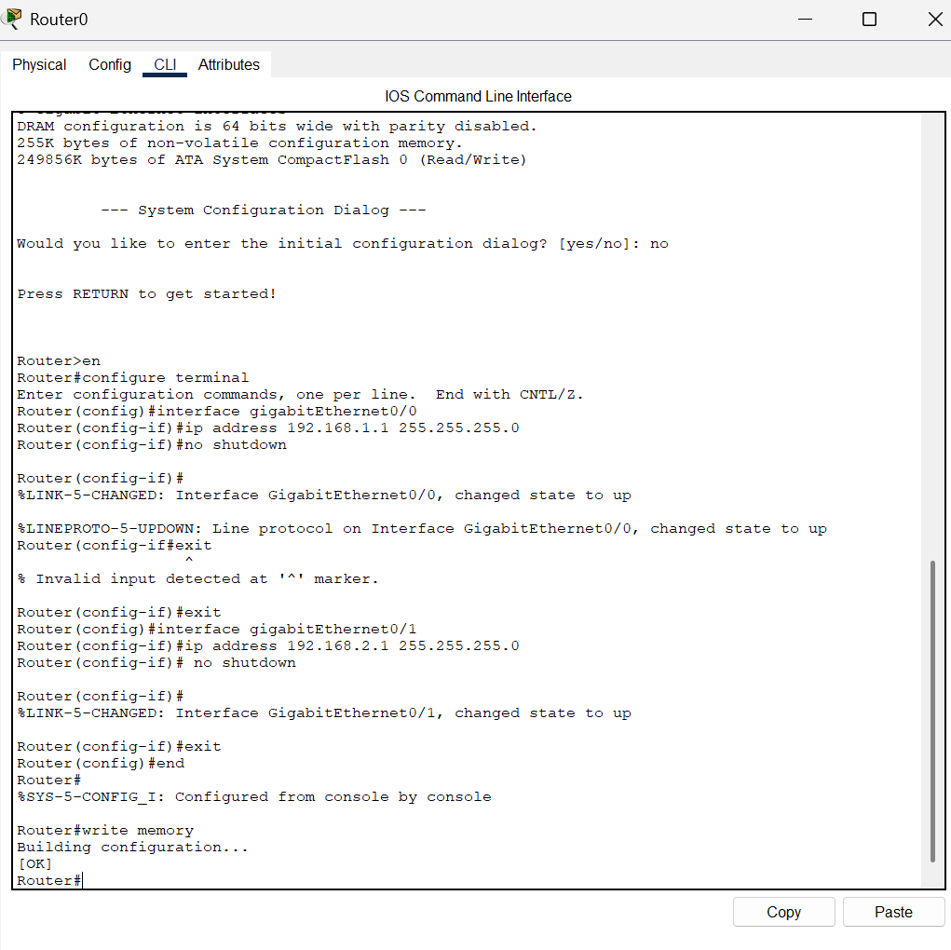
Step 5 : Verify Router
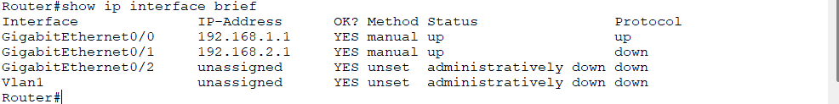
PHASE 3: Configure PCs
Step 6: Click each PC- Desktop- IP configuration
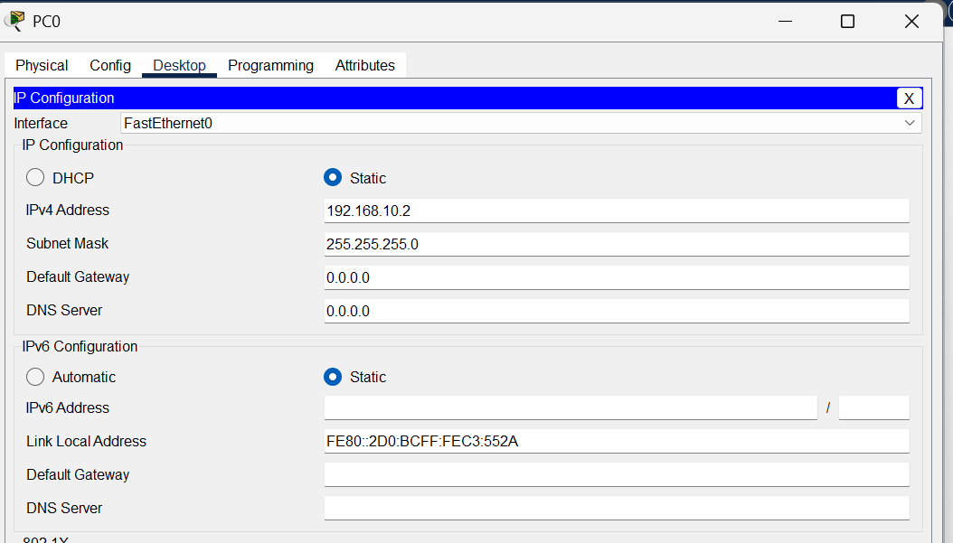
PHASE 4 : STATIC ROUTING
Step 7: Add static Routes on Router
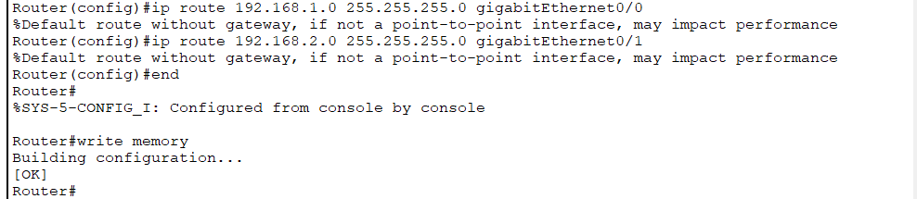
PHASE 5: TEST CONNECTIVITY
Step 8: Ping from PC1
.Click PC1 – desktop – command prompt
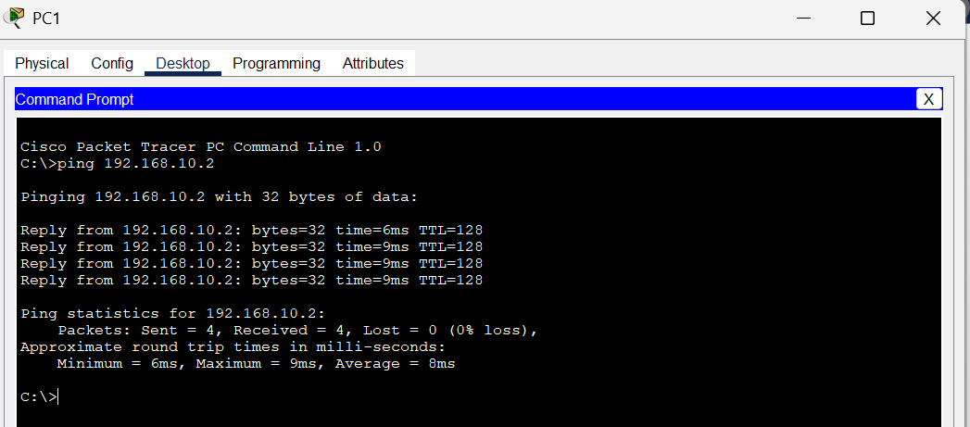
PHASE 6: SIMULATE TRAFFIC
Step 9: Use add simple pdu
. Click the envelope icon
. Click PC0 then click PC1
. A packet will appear on the workspace
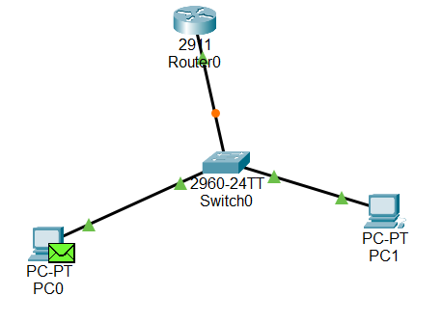
Step 10 : Switch to Simulation mode
. Click Simulation tab
. Press Play or step button
. Watch packets travel PC0 -SWITCH0- ROUTER-SWITCH-PC1
